Scientific Calculator Options

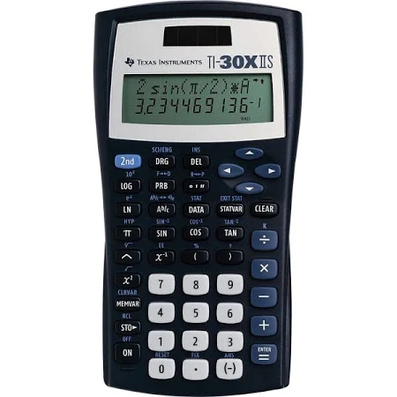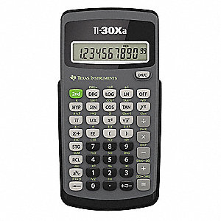

These are two common scientific calculators. Your main goal when locating a calculator is that it is a scientific calculator. They cost between $11.00 - $20.00 depending on the store.